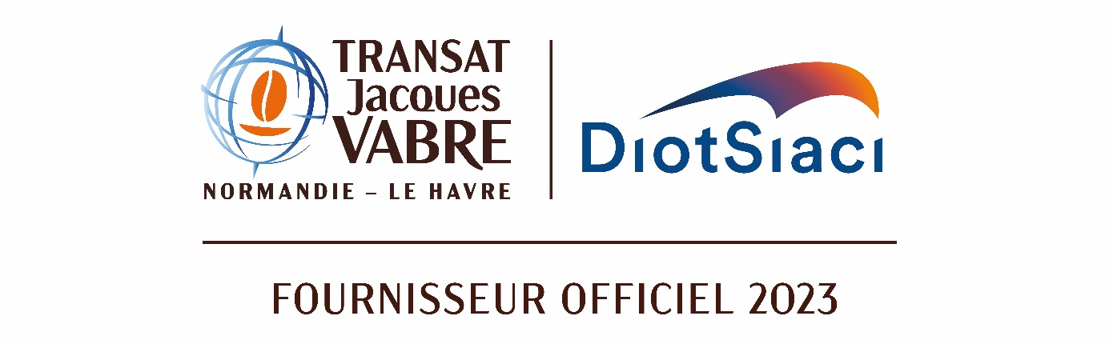
OFFICIAL SUPPLIER 2023

Press release

DIOT SIACI becomes Official Supplier to the

Transat Jacques Vabre Normandy - Le Havre

Paris, May 17, 2023 - The Diot-Siaci Group, French and European leader in corporate insurance brokerage, and the organizing partners, Le Havre, Jacques Vabre and the Normandy region, are pleased to announce their partnership for the 16th Coffee Route (Route du Café).

In celebration of its thirtieth anniversary and sixteenth Coffee Route, every two years Diot-Siaci partners with the transatlantic race connecting Le Havre in Normandy and Martinique.

With a privileged role as official supplier to the Transat Jacques Vabre Normandy Le Havre, this partnership is the result of Diot-Siaci’s:
- commitment to the French overseas territories where the Group operates through Diot-Siaci Outre-Mer
- its strong position in marine insurance
- its attachment to sailing, a sustainable sport from which its logo is inspired.

The Transat Jacques Vabre Normandy Le Havre and Diot-Siaci share common values such as excellence and team spirit, with Normandy and Martinique, two territories where the Group has a strong presence, as the anchor.

This partnership is an opportunity to experience moments of emotion and sharing with employees, clients and partners. The race starts at the end of October from Le Havre and finishes in Fort de France, with an arrival expected in the first two weeks of November.

Cédric Charpentier, Global CEO of Diot-Siaci: "We are proud of this partnership with the famous Transat Jacques Vabre Normandy Le Havre, whose values we share and which symbolizes our commitment to our clients in the French overseas territories and all over the world."

About the Transat Jacques Vabre Normandy Le Havre

The Transat Jacques Vabre Normandy Le Havre is a transatlantic, two-handed sailing race connecting Le Havre in Normandy to the coffee-producing continents. The Coffee Route was created in 1993 by the Jacques Vabre brand and the city of Le Havre and brings people together through meetings and events for everyone, organized in the villages at the start and finish points of the race, and by sharing the stories of ocean-racing sailors, which feed the imagination. The Transat Jacques Vabre Normandy Le Havre is also an eco-friendly event that contributes to the preservation of our ocean and land resources.

The race starts on October 20 in Le Havre.

About Diot-Siaci

Diot-Siaci is a leading multi-specialist consulting, insurance and reinsurance brokerage group in France and Europe, with a presence in Asia, the Middle East and Africa. Diot-Siaci designs and develops innovative solutions tailored to the needs of its clients, including large and mid-cap companies, SMEs/SMIs, and professionals, in both personal insurance and property and liability insurance. Diot-Siaci has a stable, family-owned shareholding base which means it can support its clients in their transformation by meeting their needs across the entire value chain in Property & Casualty, Marine and Cargo, Professional Third Party Liability, Employee Benefits and Consulting, and International Mobility. With almost 5,000 employees and an extensive international network, the Group operates worldwide and generated revenue of almost €800 million in 2022.

Find out more at
www.diot-siaci.com

Press relations
Havas | +33(0)7 77 16 66 08
Amélie de Bourbon Parme | Camille Houel
diot-siaci@havas.com

